→ Version

>> python -m django --version

→ Create Project

>> Django-admin startproject mysite

mysite/

manage.py

mysite/

__init__.py

settings.py

urls.py

wsgi.py

→ Create app

>> python manage.py startapp polls

polls/

__init__.py

admin.py

apps.py

migrations/

__init__.py

models.py

tests.py

views.py

à run server

>> python manage.py runserver

… runserver 8080 # Changing port

… runserver 0:8080 #Changing server’s ip and port

→ create app

>>> python manage.py startapp polls

→ Database setup in settings.py

…

DATABASES = {  
 'default': {  
 'ENGINE': 'django.db.backends.mysql',  
 'NAME': 'myproject',  
 'USER': 'myprojectuser',  
 'PASSWORD': 'password',  
 'HOST': 'localhost',  
 'PORT': '',  
 }  
}

...

**Simple flow of Django:**

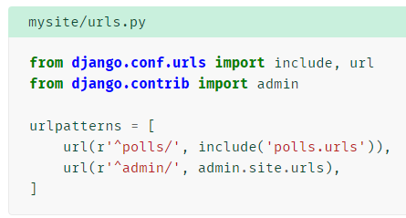

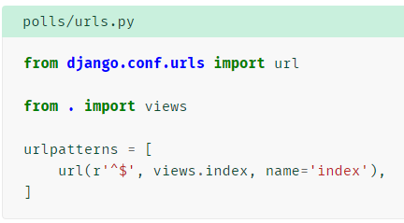

Views.index :- is method in views

Name: user defined we can use it global

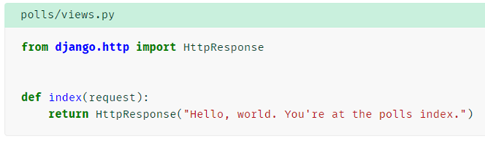

**Models example:**

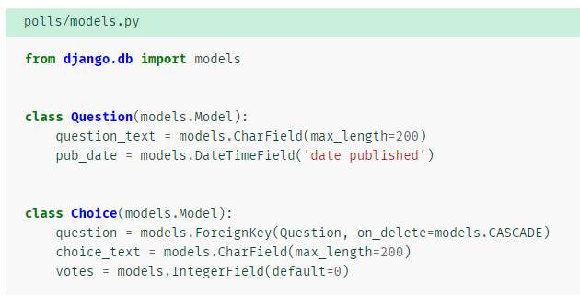

Add following code for returning string

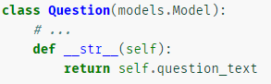

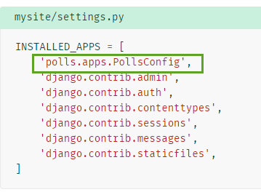

For migration first time:

**$python manage.py makemigrations polls**

**$** python manage.py sqlmigrate polls 0001

**Playing with API:**

$python manage.py shell

>>>

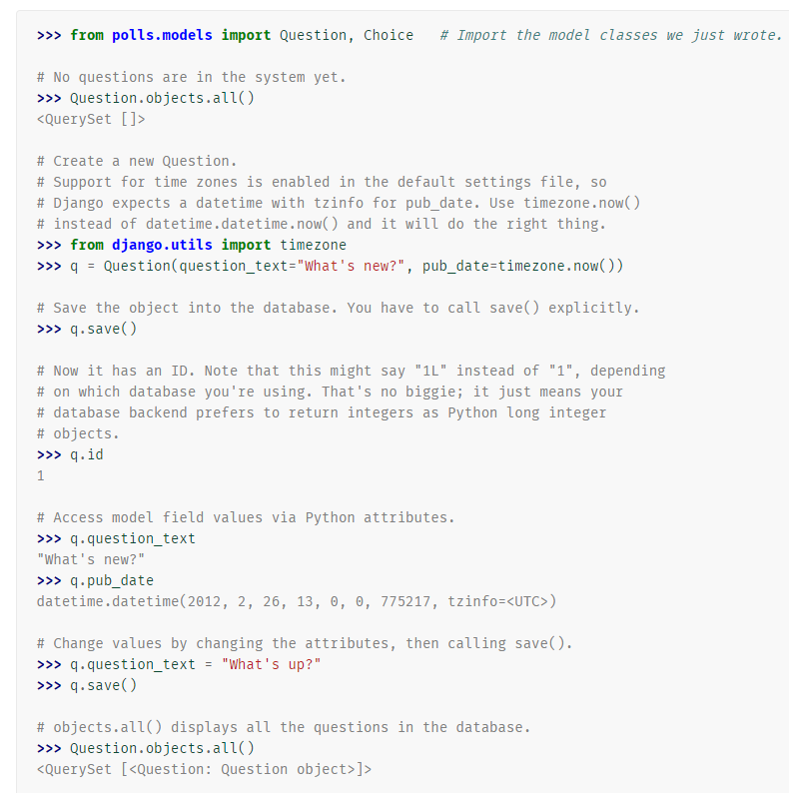





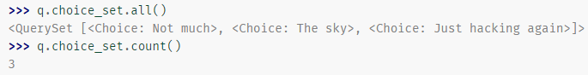

For admin access to modify app

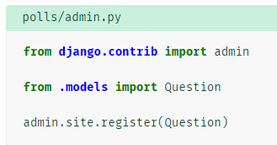

Passing values to views:

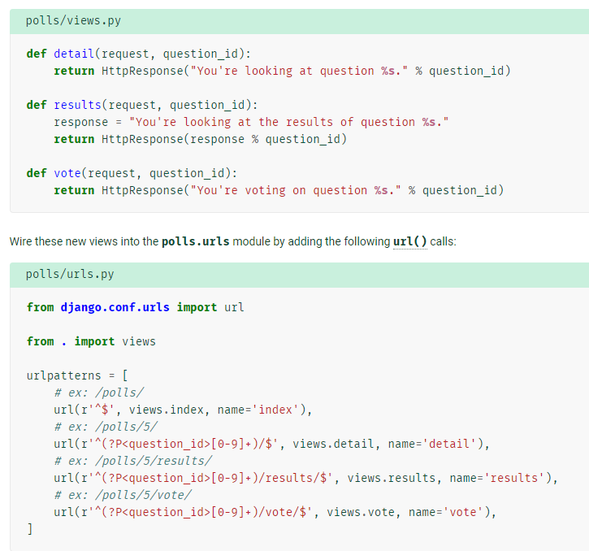

Importing models and handling data in views:

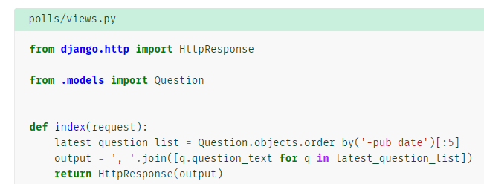

Templates:

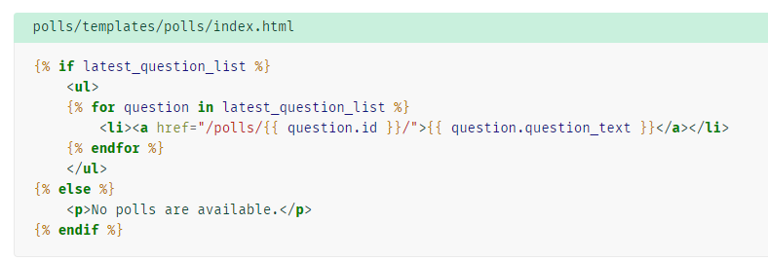

Using render;

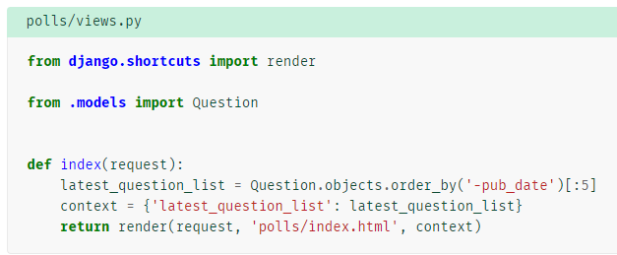

Test cases in tests.py:

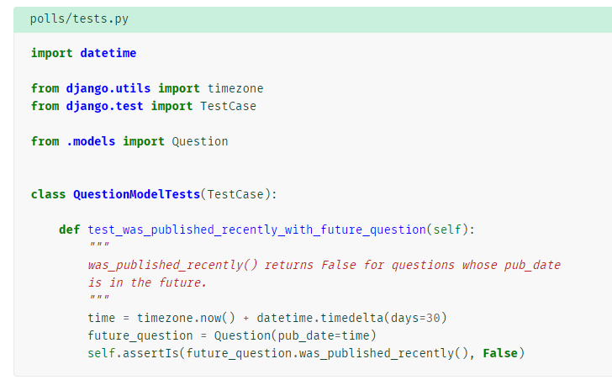

$python manage.py test polls